14.38: a)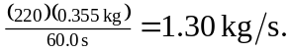 b) The density of the liquid is 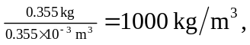 and so the volume flow rate is 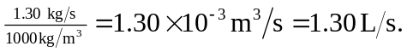 This result may also be obtained from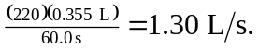 c) 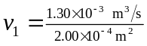
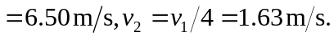
d) 